

MCA Application User Manual

June 30, 2015

**Document History**

|  |  |  |  |  |
| --- | --- | --- | --- | --- |
| **Version #** | **Author** | **Date (dd/mm/yyyy)** | **Reviewed By** | **Comments** |
| 1.0 | Shraddha Patil | 18.06.2014 | Jigar Shah | Initial Draft |
| 1.5 | Shraddha Patil | 08.07.2014 | Jigar Shah | New version release |
| 1.8 | Shraddha Patil | 28.11.2014 | Monika Bhardwaj | New version release |
| 1.9 | Ripal Patel | 15.01.2015 | Monika Bhardwaj | New version release |
| 2.1 | Ripal Patel | 30.06.2015 | Jigar Shah | New version release |

**Table of Contents**

**1** **INTRODUCTION**

**2** **MCA HOME**

**3** **OPPORTUNITY (DEALS)**

3.1 PROGRESS BAR

3.2 FUNDING APPLICATION

3.3 GRID TAB PAGE

3.4 TIMELINE IMAGE COLOR BAR

**4** **DEAL ENTRY WIZARD**

**5** **SUBMISSION WIZARD**

**6** **OFFER WIZARD**

**7** **EMAIL STIPS**

**8** **ACTIVITY COUNT ON LEAD AND OPPORTUNITY**

**9** **TRANSACTIONS**

**10** **MANAGE RENEWAL**

**11** **ADMINISTRATION PANEL**

**12** **CUSTOM LEAD CONVERT**

**13** **APPENDIX**

# **Introduction**

* MCA Application is a cloud-based Lending application, which is built to help merchants to send the application to multiple lenders, view and edit forms, automated process to send offers.
* It is a readymade framework for facilitating basic operations of the lending business, like capturing application information, submission of the application to different banks and merchants, sending offers to the merchants and so on.
* MCA Application is useful for sales representatives, underwriters and funding agencies who are associated with the lending business and use this application for process automation.
* The *Table 1* provides the list of objects of MCA application with its significance.

**Table 1 – Objects of MCA Application**

|  |  |  |
| --- | --- | --- |
| **Sr. No.** | **Term** | **Description** |
|  | Accounts | Merchants associated with the lending business. |
|  | Campaigns | User can generate marketing campaigns for the lending services, including direct mail program, seminar, print advertisement, email or any other marketing initiative. |
|  | Contacts | Sales representatives, underwriters and funding agencies who are associated with the lending business. |
|  | Contracts | Business agreements associated with the Account. |
|  | Leads | User can generate potential opportunities for lenders. |
|  | Offers | Get offers from lenders. |
|  | Opportunity (Deals) | Deals to get credit for their business. |
|  | Payables | Refer to the balance amount to be paid by the individual and companies. |
|  | Receivables | Refer to amount received from an individual and the companies. |
|  | Submissions | Acknowledgement of application by entering the lender’s credit score, the number of years for which the lender is in business, the minimum monthly deposit value defined by the lender and by selecting the industry of the lender. |
|  | Syndications | A group of individuals or organizations combined or making a joint effort to undertake some specific duty or carry out specific transactions or negotiations. |
|  | Transactions | Communication or movement carried out between the lenders and the merchants to exchange an asset for payment. |

# **MCA Home**

* The MCA application home page gives an overview as well as links to reach to the various functionality of MCA application.
* The MCA application home page contains the icons to reach to the various modules of the MCA application. The users can navigate the required module by clicking on that module icon.

For example: On click of **Campaign** icon, Campaign Dashboard will be displayed which gives the detail count of top five Campaigns (by Revenue) generated in the current month.

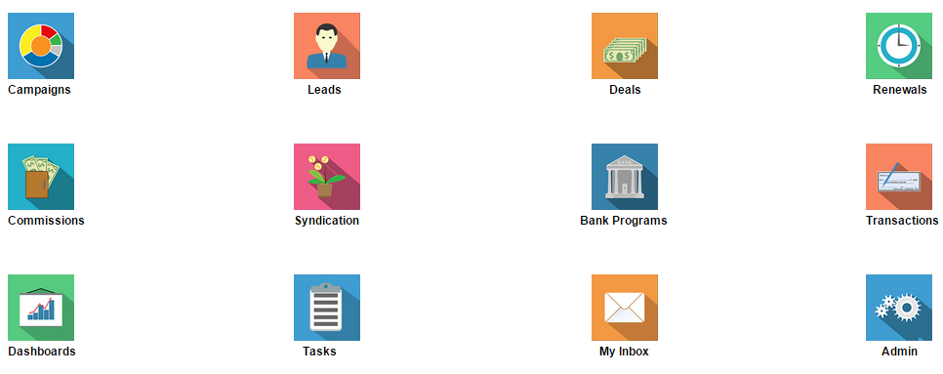

**Figure 1 – MCA App Home Page**

* The MCA application home page also displays the **Statistics** information of the current month.



**Figure 2 – Statistics Information Screen**

* The MCA application home page also displays the **Charts.** It displays the graphical representation of the application data.

For e.g. Opportunity pipeline, Funded MTD, Funded Renewal Eligibility etc.

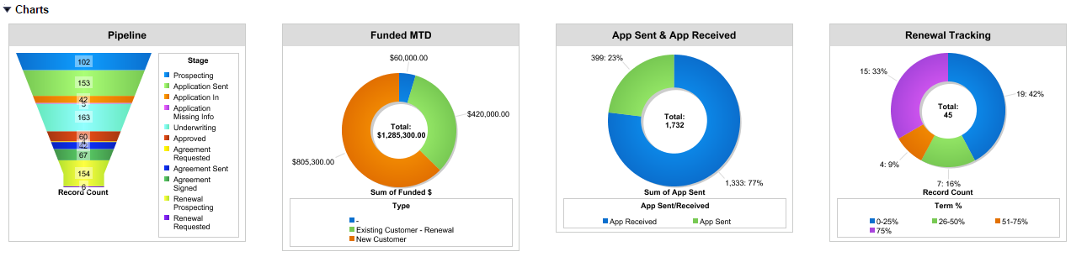

**Figure 3 - Charts**

# **Opportunity (Deals)**

* Opportunity allows the user to create a new opportunity for an account holder. User can create multiple opportunities for a single account.
* Opportunities are deals to get credit for their business. User can enter merchant details, requested amount of fund, the probability to get funding and the outstanding credit amount of merchant, if any.

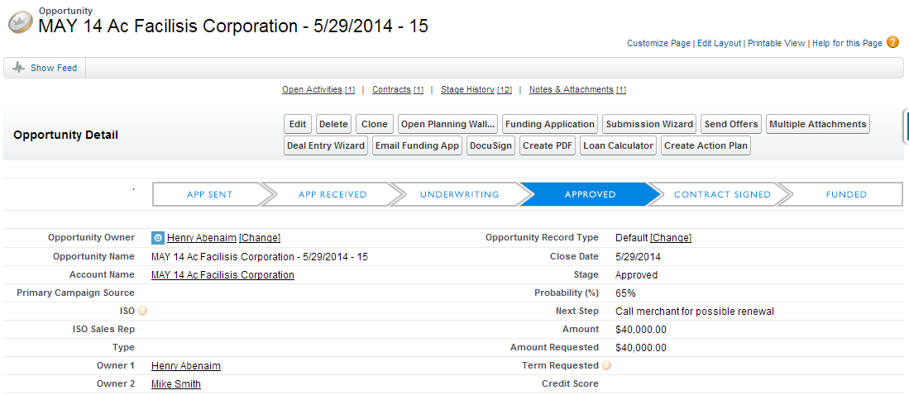

**Figure 4 – Opportunity / Deals Details**

* Opportunity has the following functionalities within it:

## **Progress Bar**

* + The Progress Bar displays all the stages of funding request for the opportunity.
  + While creating a new Opportunity record or modifying existing opportunity record, the stages of Progress bar will change according to the funding request stage.

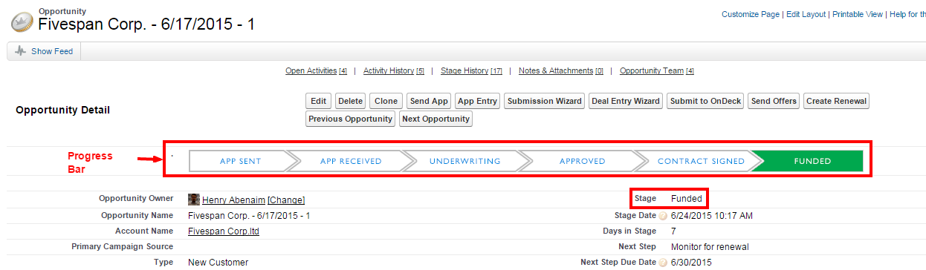

**Figure 5 – Progress Bar**

## **Funding Application**

* + This functionality allows the user to create an application for funding requests. The users need to enter merchant’s business details, business owner’s details and the bank details for the merchant’s account.
  + To navigate **Funding Application Form,** click **Funding Application** button. It will open Funding Application form.

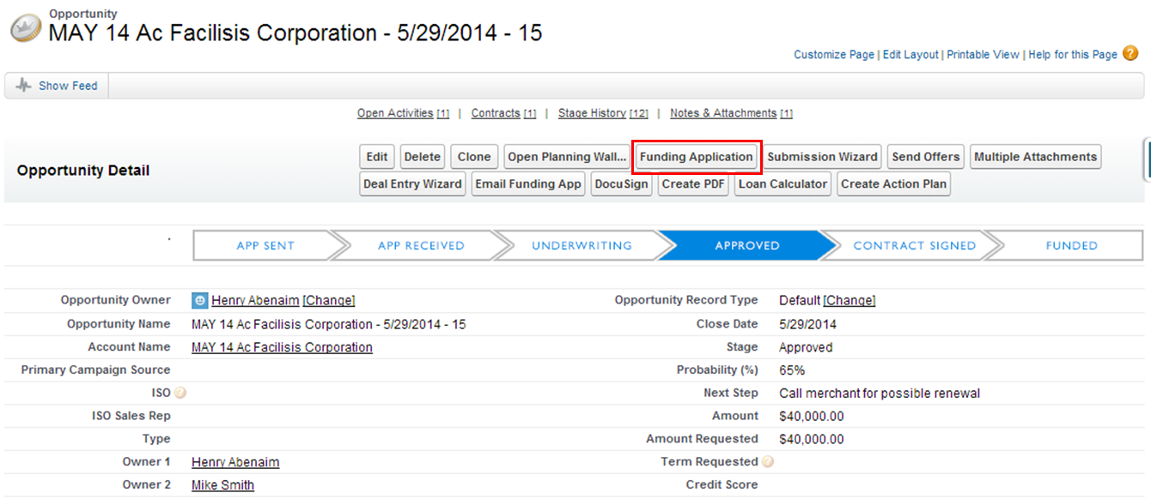

**Figure 6 – Opportunity Detail Page**

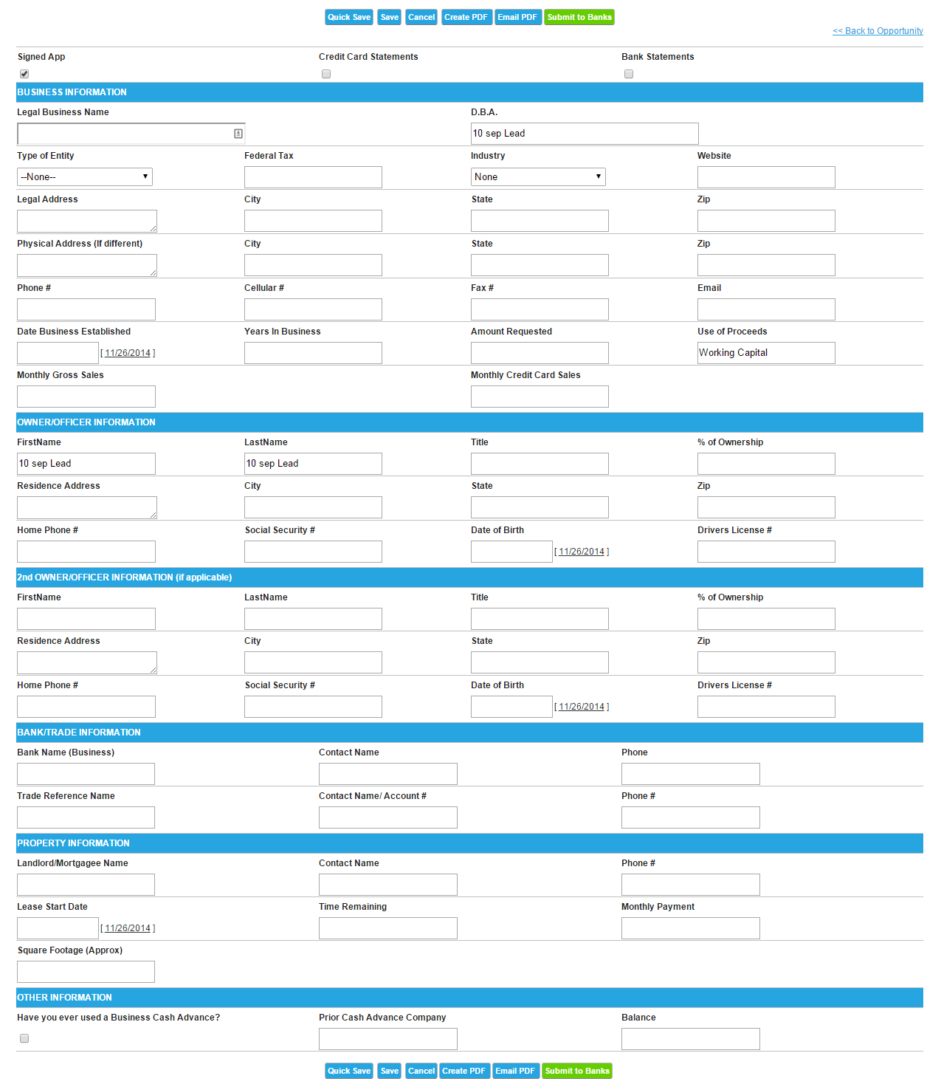

**Figure 7 – Funding Application Form**

* + To save the Funding Application Form, click **Save** button. It will save the changes and navigate the Funding Application form.
  + The Funding Application Form has the following two functionalities:
  1. **Create PDF:** User can generate a PDF version of the funding application. For this, the user has to click **Create PDF** button provided on the application form. Once the user clicks it, a PDF version of the funding application will download automatically.
  2. **Send PDF:** User can send a PDF version of the funding application to a merchant. For this, the user has to click **Send PDF** button provided on the application. Once the user clicks it, the wizard to send an email to a merchant will be populated with the PDF attachment of the funding application.

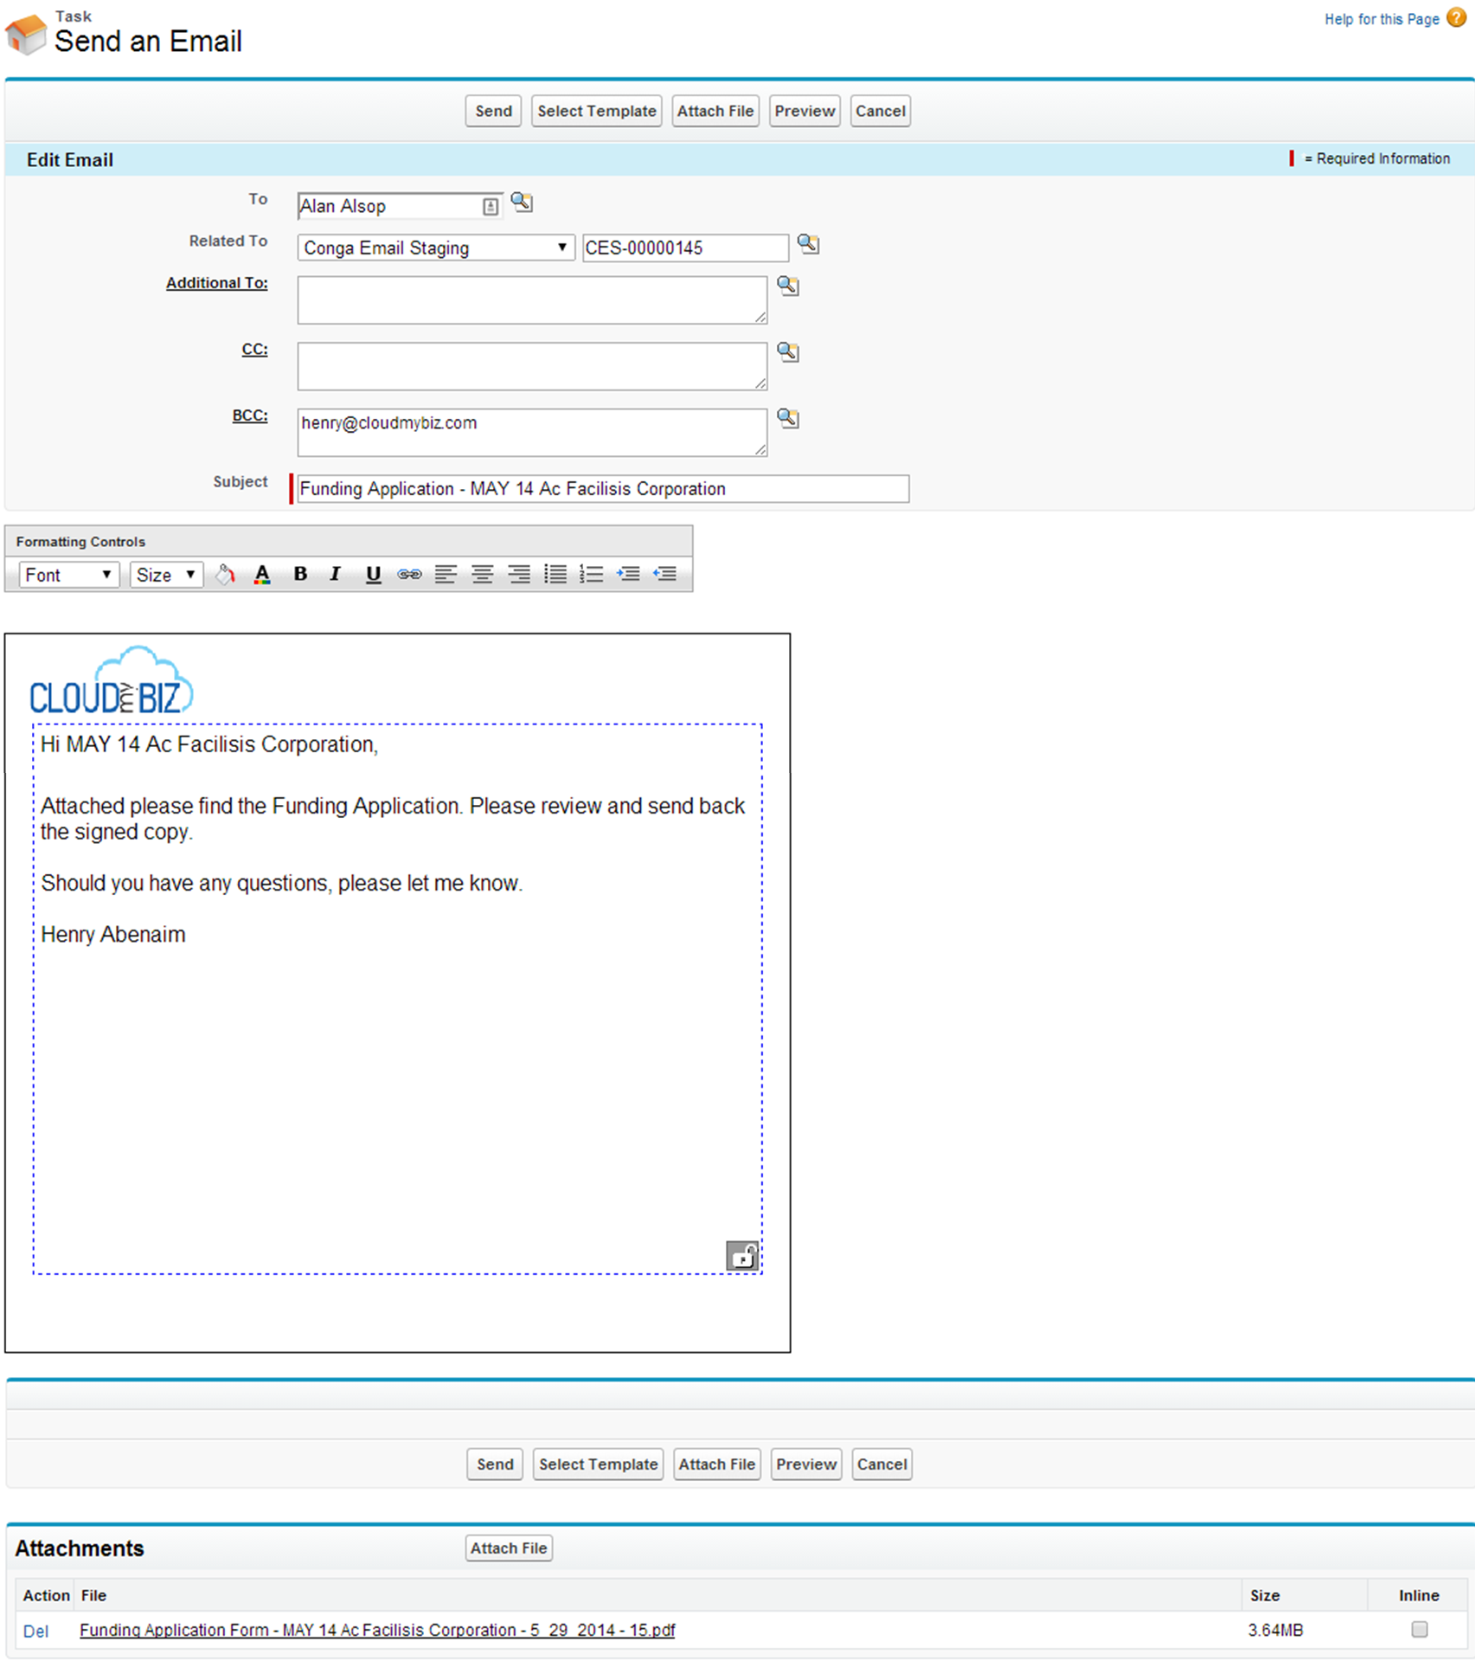

**Figure 8 – Wizard to Send an Email**

## **Grid Tab Page**

Grid Tab Page contains related information of all child object of opportunity.

* **Submissions:** It contains submission information of related opportunity including submission name, funder details, date submitted etc.

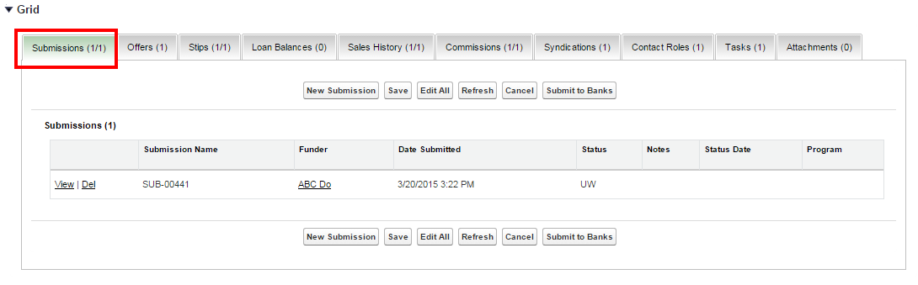

**Figure 9 – Submission Grid Tab Page**

* **Offers:** It contains offer information of related opportunity including deal type, funding amount, payback amount etc.

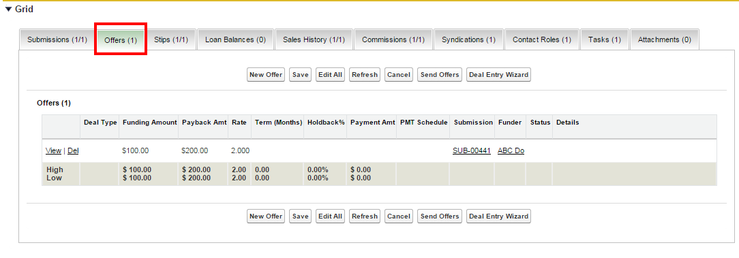

**Figure 10 – Offers Grid Tab Page**

* **Stips:** It contains stip information of related opportunity including stip name, type, status etc.

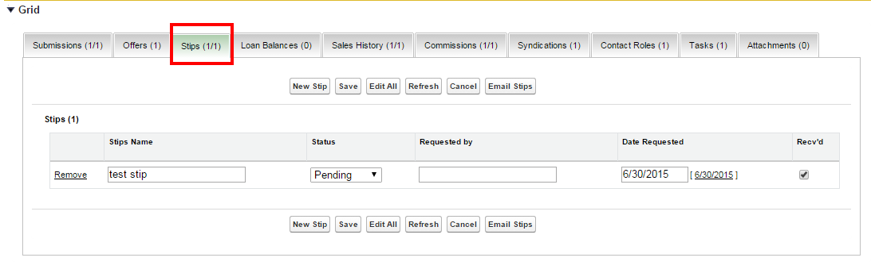

**Figure 11 – Stips Grid Tab Page**

* **Loan Balances:** It contains loan balance information of related opportunity including loan balance name, funder, balance etc.

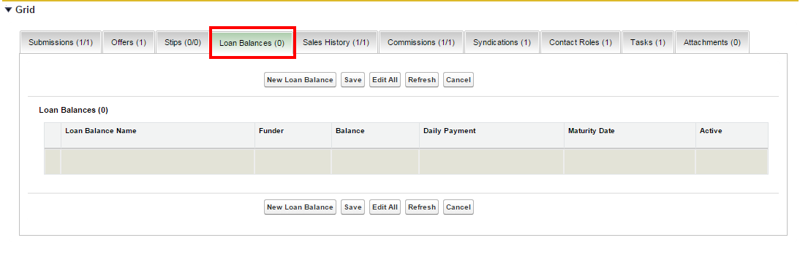

**Figure 12 – Loan Balances Grid Tab Page**

* **Sales History:** It contains sales history information of related opportunity and displays bank accounts and credit card details.

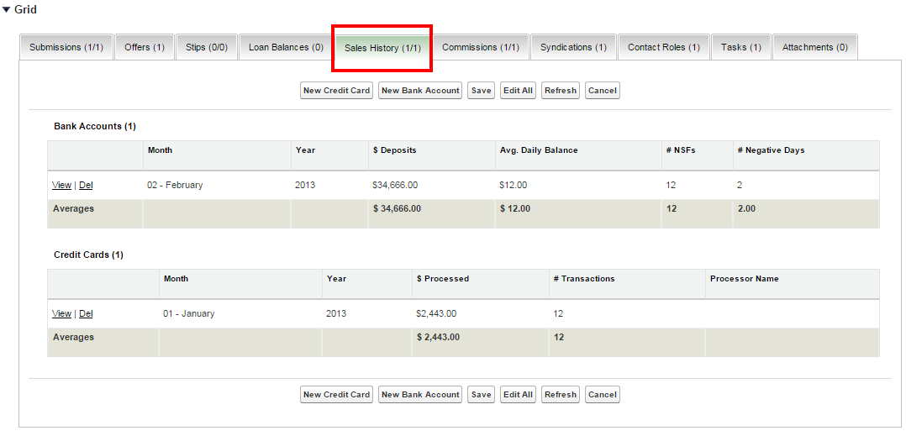

**Figure 13 – Sales History Grid Tab Page**

* **Commissions:** It contains payable and receivable commission details of related opportunity.

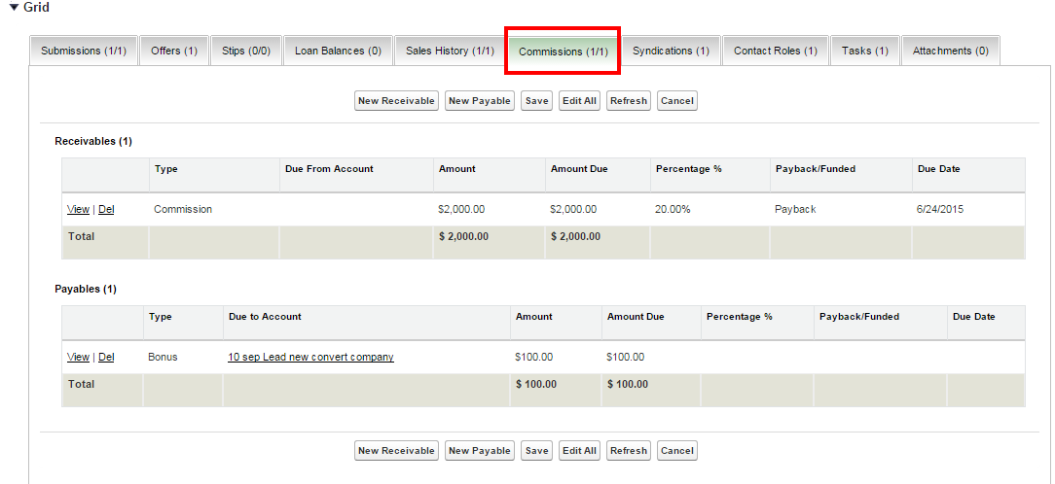

**Figure 14 – Commissions Grid Tab Page**

* **Syndications:** It contains syndication details of related opportunity including syndication amount, servicing fee, commission fee etc.

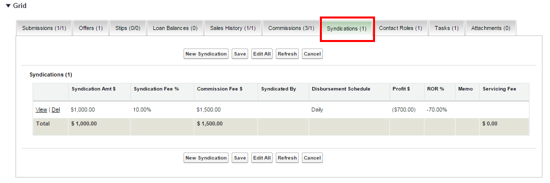

**Figure 15 – Syndications Grid Tab Page**

* **Contact Roles:** It shows the information of opportunity contact roles.

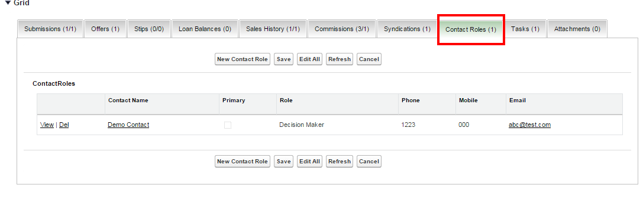

**Figure 16 – Contact Roles Grid Tab Page**

* **Tasks:** It shows the task related to opportunity including subject, due date of task, priority etc.

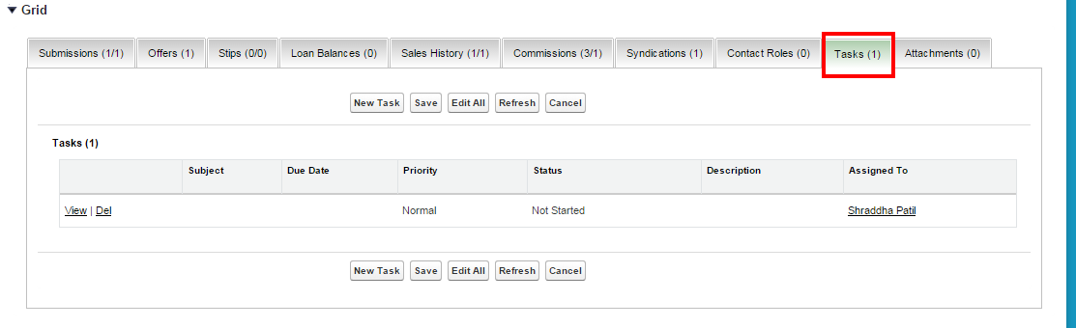

**Figure 17 – Tasks Grid Tab Page**

* **Attachments:** It shows the attachments related to opportunity including title, description, type, etc.

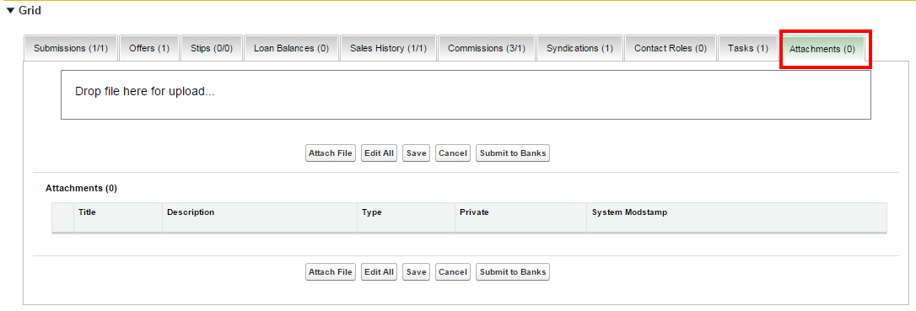

**Figure 18 – Attachments Grid Tab Page**

**2.4 Timeline Image Color Bar**

1. The Timeline Image Color Bar will display all the stages of funding request for the opportunity.
2. While creating a new Opportunity record or modifying existing opportunity record, the stages of Timeline Image Color Bar will change according to the funding request stage.

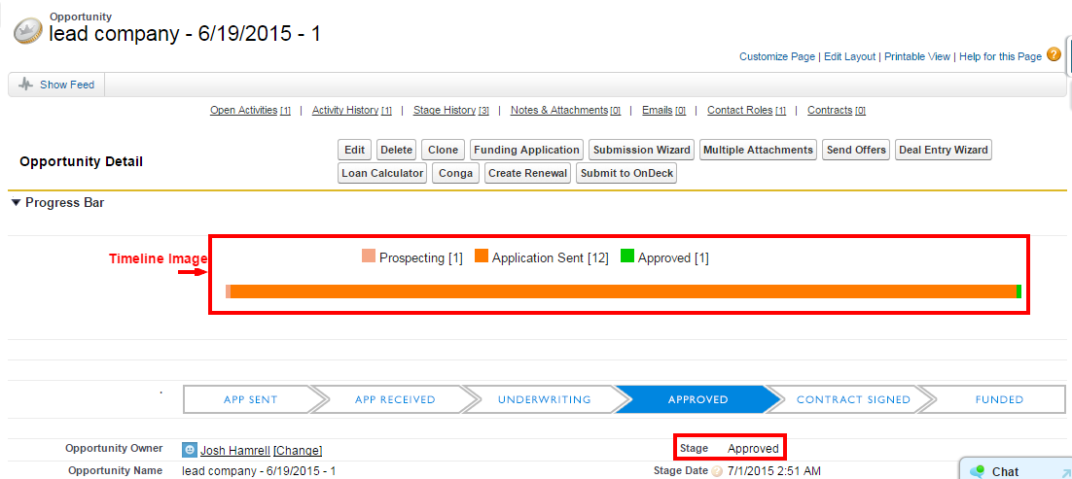

**Figure 19 – Timeline Image Color Bar**

# **Deal Entry Wizard**

* **Deal Entry Wizard** functionality allows the user to create the contract for renewal corresponding to opportunity. User can select an **Offer** from the displayed offers list or can add new one. Once the offer is selected, the wizard will display the **Deal Information**. Deal Information screen maps the information of the selected offer to the corresponding Deal. User can update the **Deal Information**, **Receivables, Payables and Syndication** records of the corresponding Deal. It also displays the sum of Receivables, Payables and Syndication amounts. The Contract renewal information would automatically updated into the corresponding opportunity record.
* Follow the steps given below to create the contract for renewal:

1. Select the **Opportunity** record and then click **Deal Entry Wizard** button.

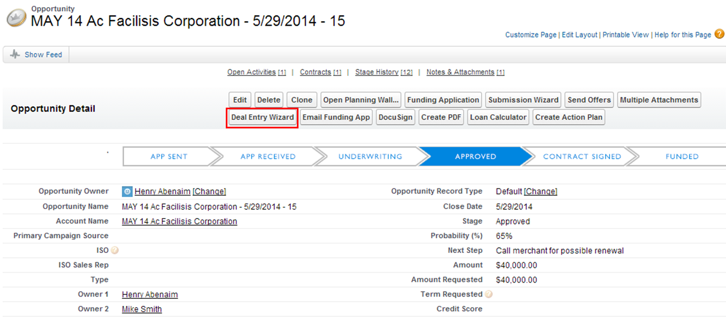

**Figure 20 – Opportunity Detail Page**

1. On click of **Deal Entry Wizard** button, **Offers** Screen will display from which the users can select an Offer. The users can also add new offers for the corresponding Opportunity. To create the new Offer –
   1. Click **Add Row** button.
   2. Fill the details and then click **Quick Save** button.

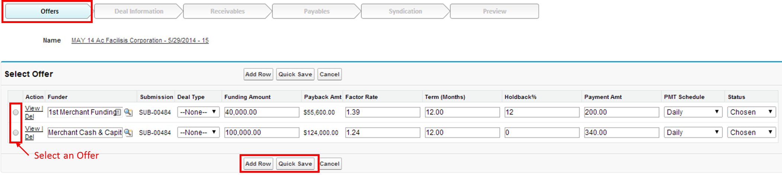

**Figure 21 – Offers Screen**

1. Click the option button to select an **Offer**. On this, the application will automatically redirected to the **Deal Information** screen with details of the selected offer.

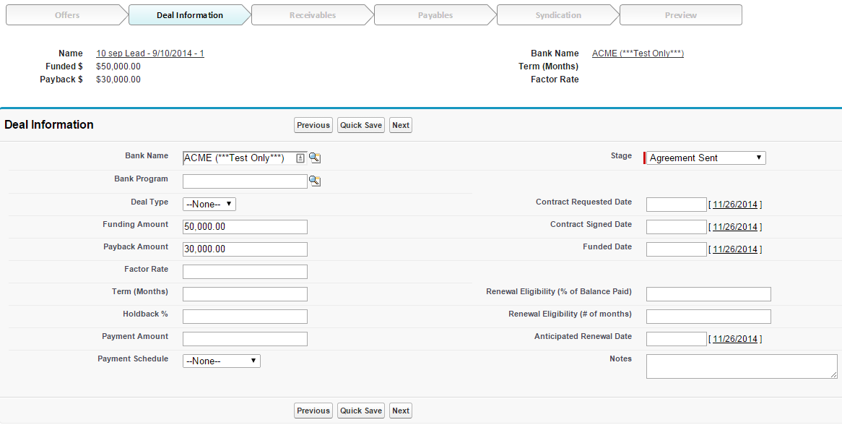

**Figure 22 – Deal Information Screen**

1. Edit and update the **Deal Information**, if required and then click **Quick Save** button.
2. Click **Next** button to navigate the **Receivables** records.

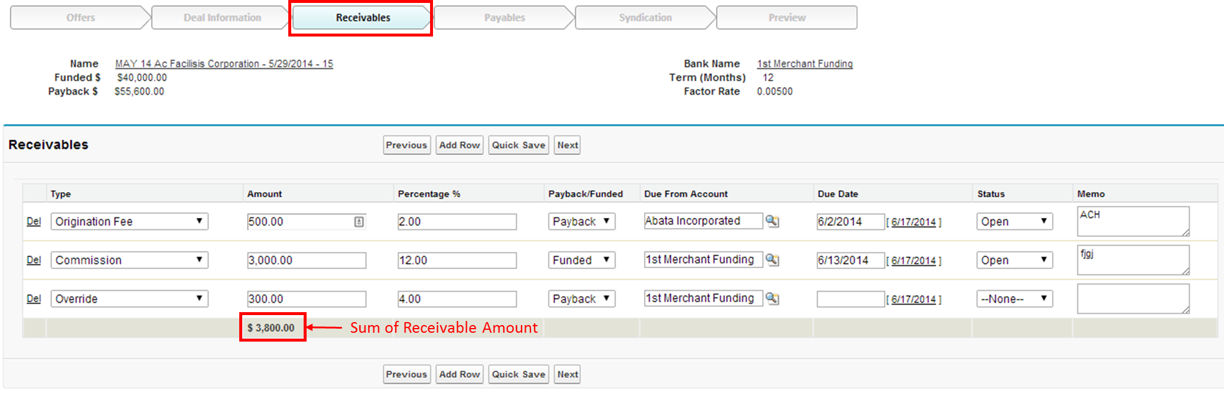

**Figure 23 – Receivables Screen**

1. Edit and update the **Receivables** records, if required and then click **Quick Save** button.
2. Click **Next** button to navigate the **Payables** records.

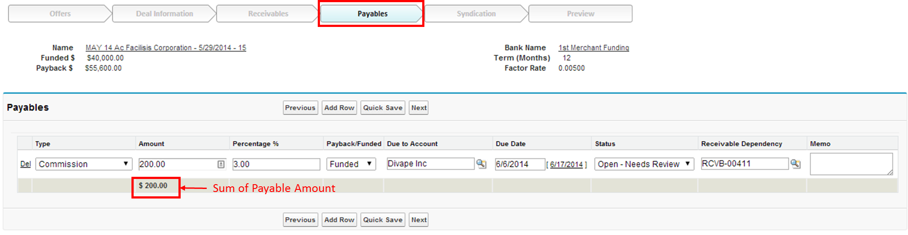

**Figure 24 – Payables Screen**

1. Edit and update the **Payable** records, if required and then click **Quick Save** button.
2. Click **Next** button to navigatethe Syndication records.

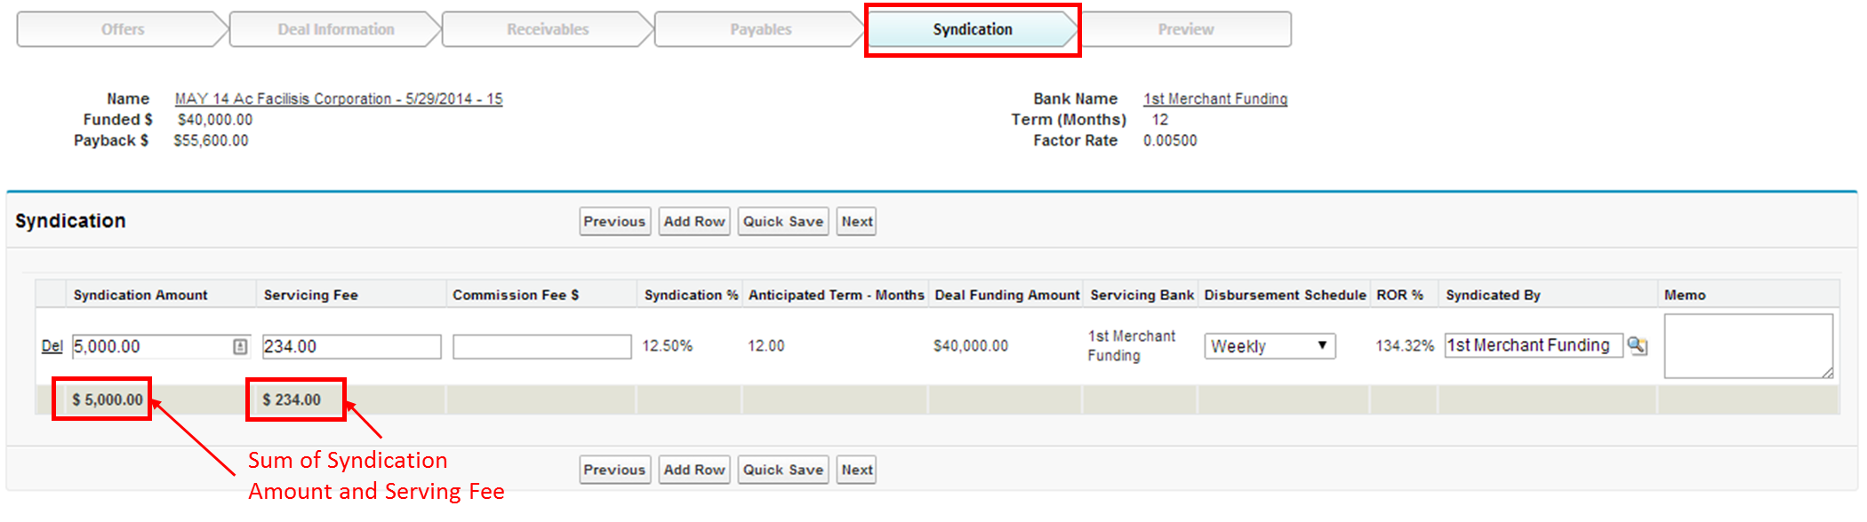

**Figure 25 – Syndication Screen**

1. Edit and update the **Syndication** records, if required and then click **Quick Save** button.
2. Click **Next** button to **Preview** the created contract.

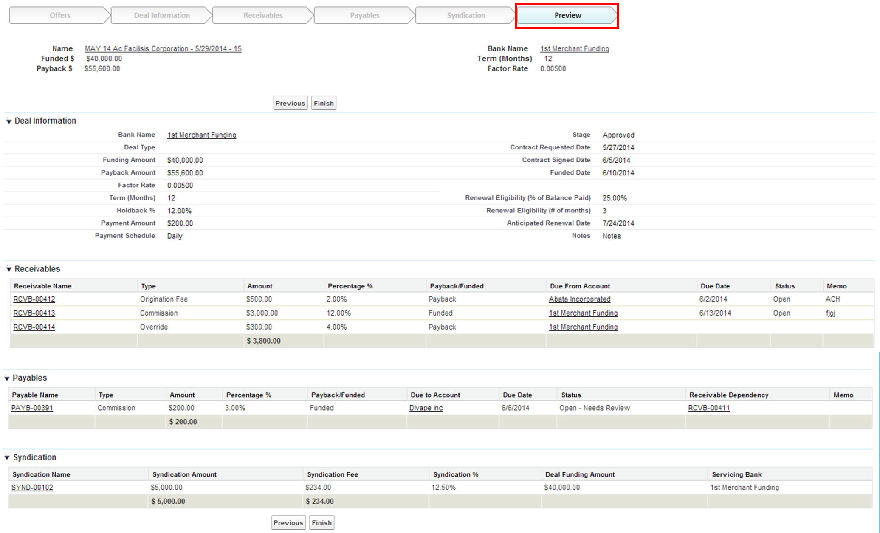

**Figure 26 – Preview of Deal Entry Wizard**

# **Submission Wizard**

* **Submission Wizard** functionality allows the user to submit an application to multiple lenders.
* User can select lenders to whom he wants to send an application by entering lender’s credit score, the number of years for which the lender is in business, the minimum monthly deposit value defined by the lender and by selecting industry of the lender. Once the entered category is filtered, submission wizard will display the preferred programs.
* The user needs to select programs from the displayed list and uploaded documents to send an application for processing to the lenders. An opportunity would automatically go into underwriting stage after submission of an application.
* Follow the steps given below to send application for processing to the lenders:

1. Select the **Opportunity** record and then click **Submission Wizard** button.

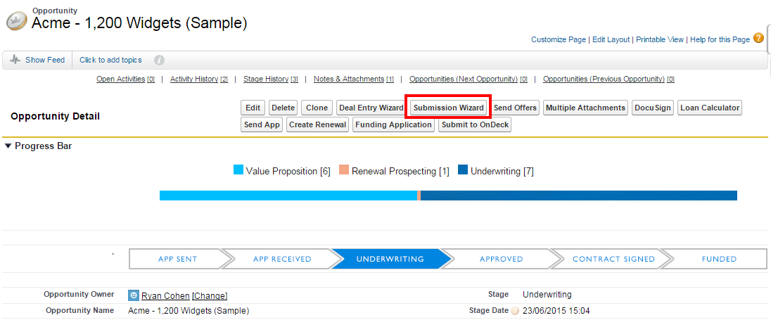

**Figure 27 – Opportunity Detail Page**

1. On click of **Submission Wizard** button, **Submission Wizard** will display from which the users can filter the lenders criteria and can select the Program.

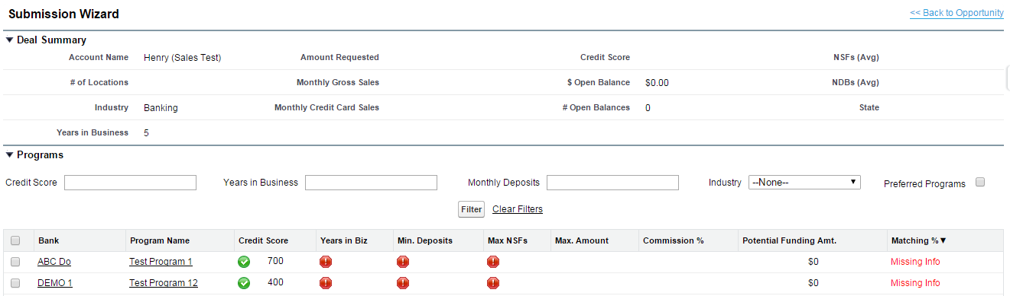

**Figure 28 – Submission Wizard Screen**

1. Enter the required criteria such as credit score, the number of years for which the lender is in business, the minimum monthly deposit value defined by the lender and by selecting industry of the lender to filter the lender categories. Click **Filter** button to categorize the lenders according to entered criteria.
2. Select the checkbox provided in front of the **Program** record. On this, attachment of the corresponding Program will be added into the Attachment section.

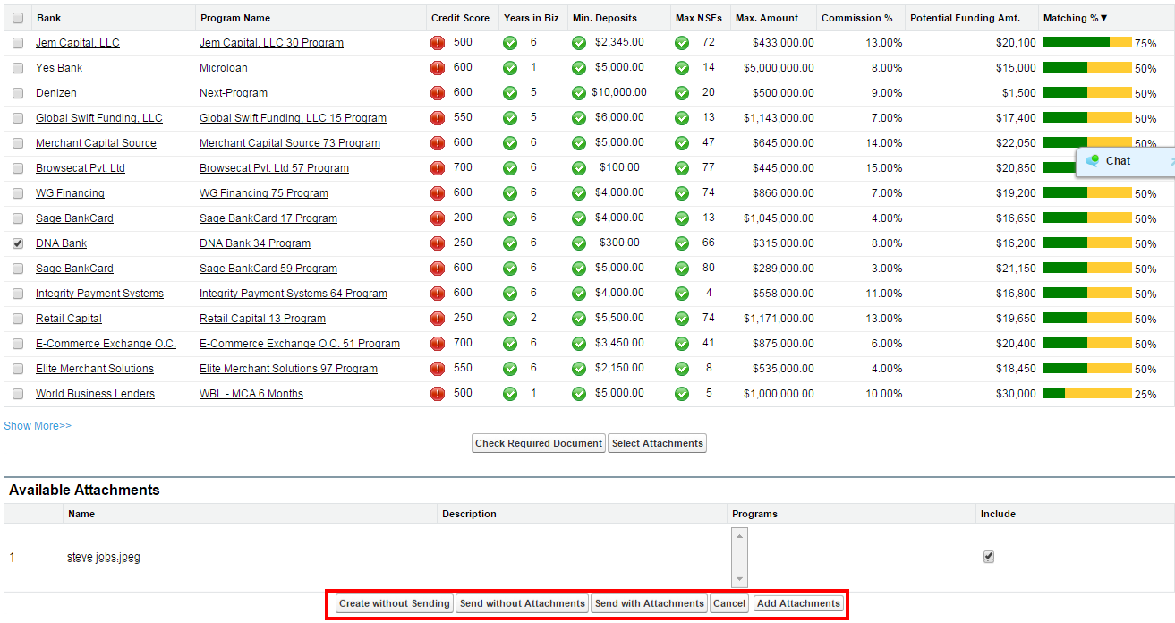

**Figure 29 – Submission Wizard Screen**

1. Click **Add Attachments** button to add new attachments, if required. Users can either drag and drop file for upload or can browse it for upload.

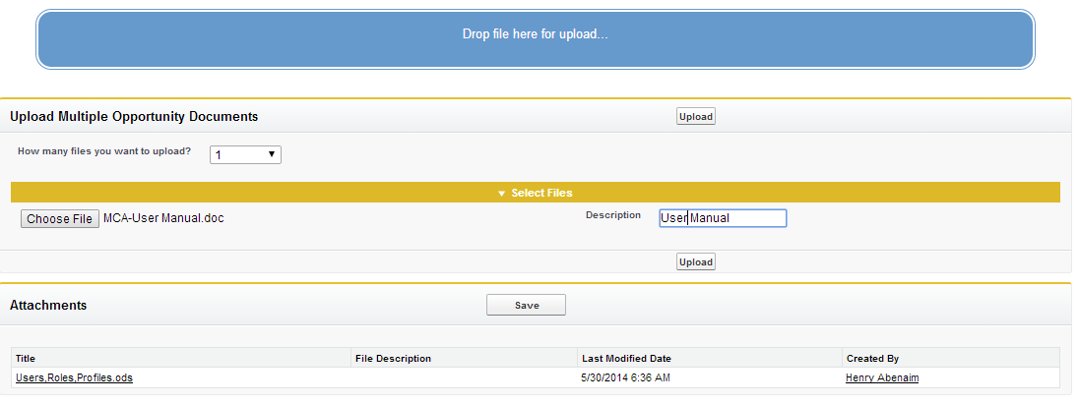

**Figure 30 – Screen to Add Multiple Attachments**

1. The Submission Wizard has the following two functionalities to send an application for the processing to multiple lenders:
   1. **Send without Attachments:** User can send the email without the attachments. For this, the user has to click **Send without Attachments** button provided on the Submission Wizard. Once the user clicks it, the email without attachments will automatically sent to the email addresses mentioned in the program record.
   2. **Send with Attachments:** User can send the email with the attachments. For this, the user has to click **Send with Attachments** button provided on the Submission Wizard. Once the user clicks it, the email with attachments will automatically sent to the email addresses mentioned in the program record.

# **Offer Wizard**

* **Offer Wizard** functionality allows the user to email received offers to the merchant. User can send chosen offers to the merchant. After the email has been sent to the merchant all the sent offers will be marked as sent and will not be populated next time.
* Follow the steps given below to send the chosen offers to the merchants:

1. Select the **Opportunity** record and then click **Send Offers** button.

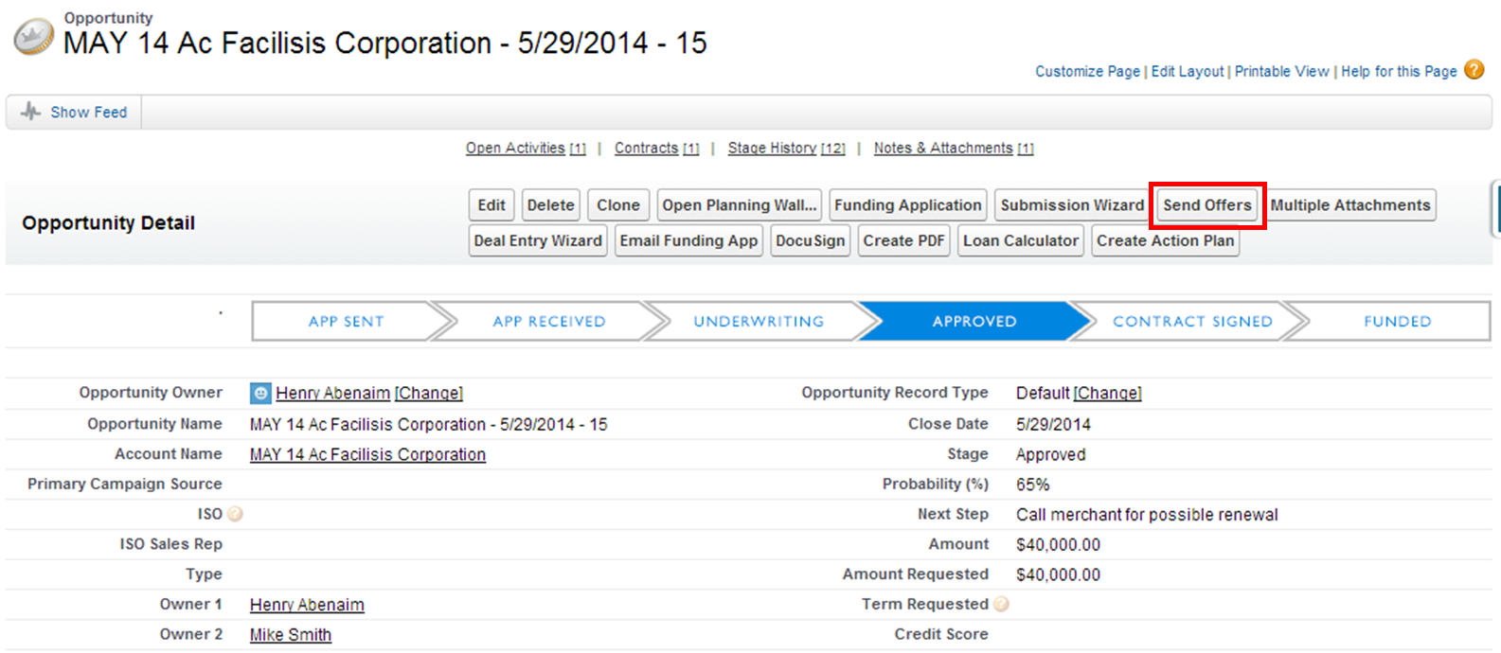

**Figure 31 – Opportunity Detail Page**

1. On this, the email wizard with chosen offers will display and click **Send** button to send the email of chosen offers to the merchant.

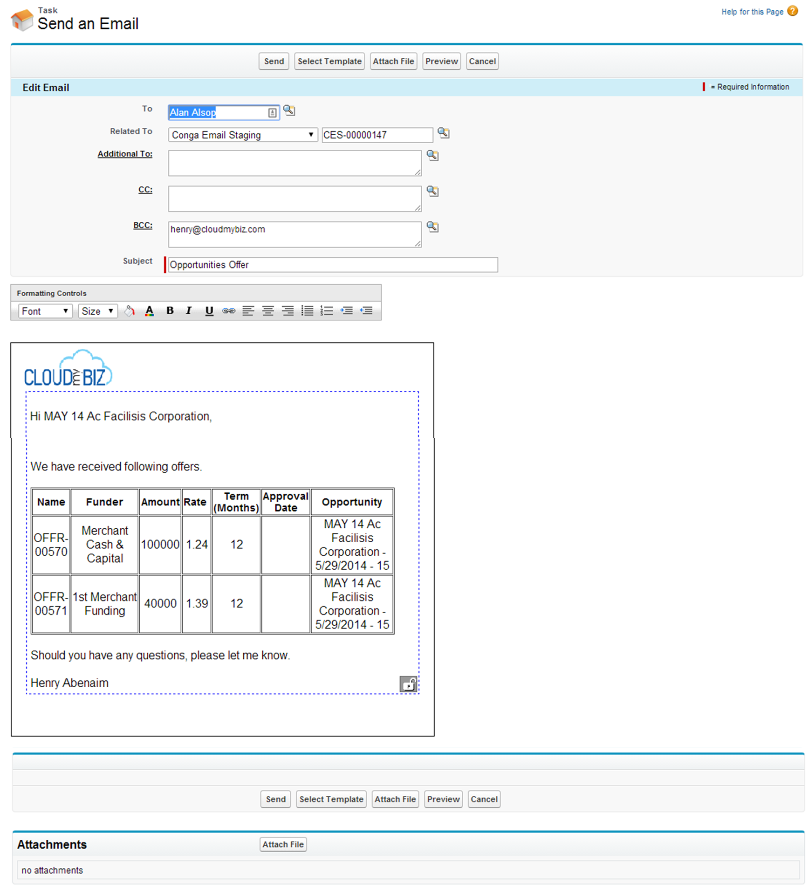

**Figure 32 – Send Chosen Offers**

# **Email Stips**

* Email Stips functionality allows the users to send an Email with details of Open Stips to the Owner associated with particular Opportunity.
* Follow the steps given below to send the Open Stips to the Owner1:

1. Go to the **Opportunity** Record.
2. Click **Stips** tab, under **Tabbed Related Objects** Section.

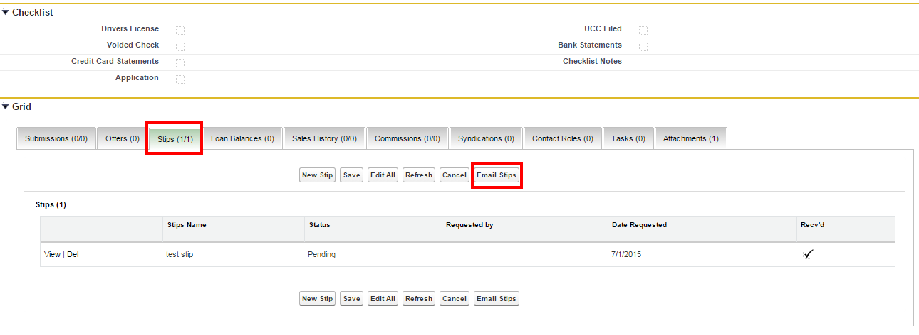

**Figure 33 – Email Stips Button on Opportunity Detail Page**

1. Click **Email Stips** button. It will redirect to the send an Email page with Owner1 detail associated with Opportunity.



**Figure 34 – Owner1 Information on Opportunity Detail Page**

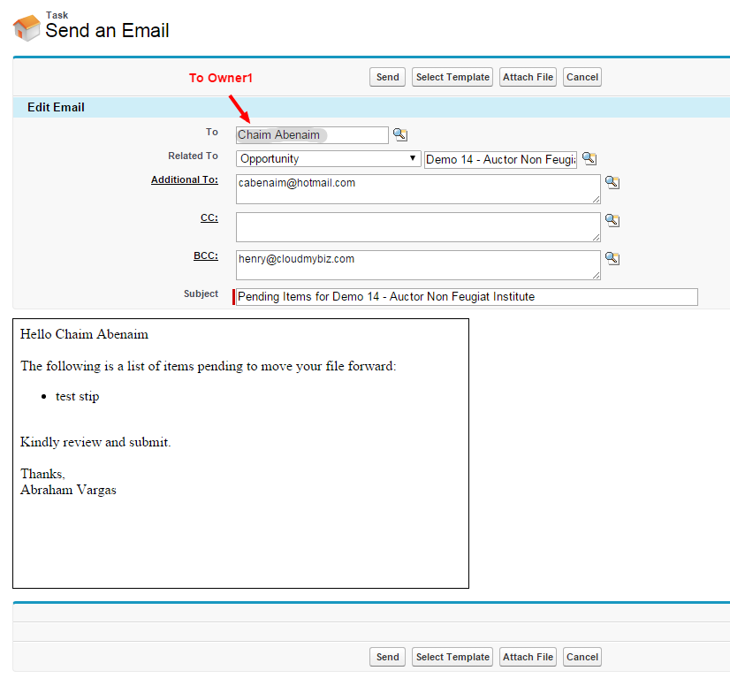

**Figure 35 – Send an Open Stips to Owner1**

# **Activity Count on Lead and Opportunity**

* **Activity Count** functionality calculates the count of the completed Tasks associated with a particular Lead and Opportunity record and displays the same in the **Activity Count** field on Lead and Opportunity.
* Select the **Opportunity** record and check the **Activity Count** when task and event created for the associated opportunity.

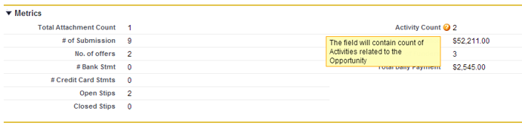

**Figure 36 – Activity Count on Opportunity**

# **Transactions**

* Transaction functionality consists of debiting the source account, crediting the target account, and recording the fact that this occurred.
* Follow the steps given below to add new transaction record:

1. Click the **Transactions** icon provided on MCA Home page. It will navigate to the page, which enables the user to create the New Transaction record.
2. Click **New Transaction** button.

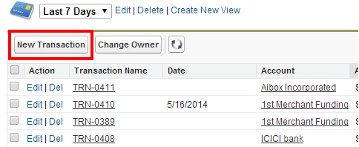

**Figure 37 – Screen to Create New Transaction**

1. On this, Transaction Record Type screen will display. Select a **Transaction Record Type** for the new transaction.

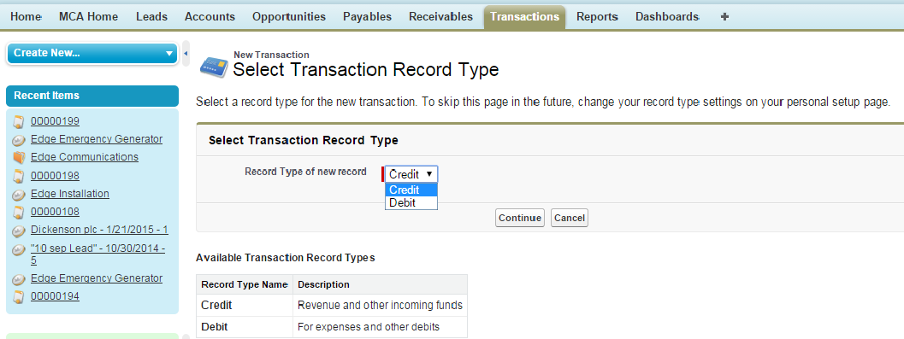

**Figure 38 – Available Transaction Record Types**

1. Click **Continue** button. It will redirect the user to transaction information screen where the users can fill the information related to the new transaction.
2. Click **Account lookup**, which will populate the list of Accounts. Select an Account for transaction.

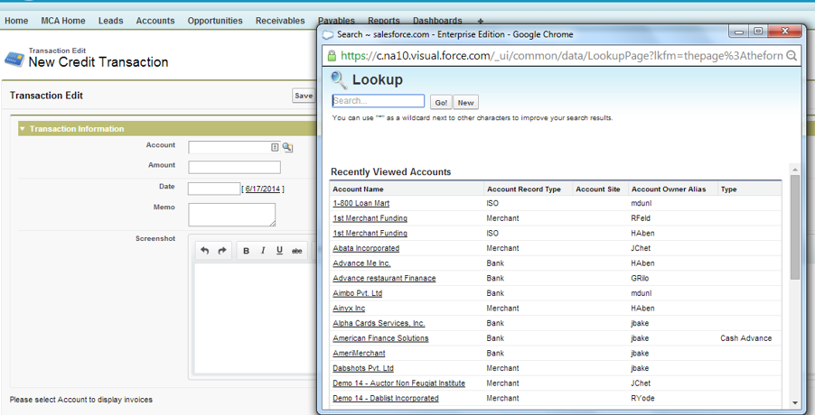

**Figure 39 – New Credit Transaction Information**

1. If transaction record type is Credit, it will display the records of **Receivables** related to that account whereas if transaction record type is Debit, it will display the related **Payable** records.

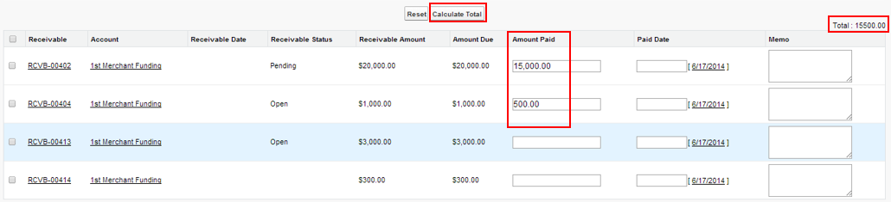

**Figure 40 – Receivable Records Screen**

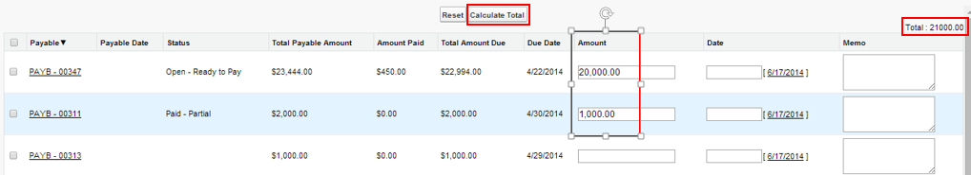

**Figure 41 – Payable Records Screen**

1. Click **Save** button. On this, the detail page of Transaction record will display. If the status is pending, the users can do Transaction using Create New Transaction Line Items.

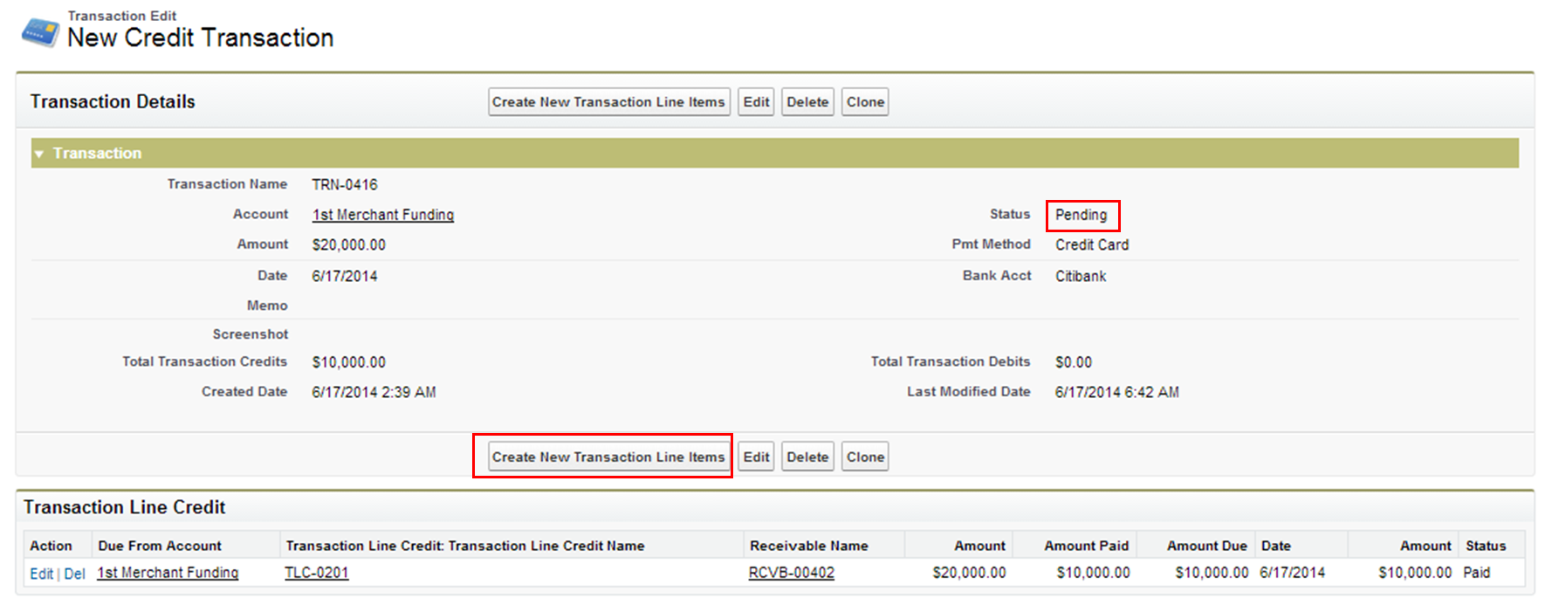

**Figure 42 – Transaction Record Details**

# **Manage Renewal**

* **Manage Renewals** process provides the ability to User to update or send Opportunities which are eligible for Renewal.
* On click of **Renewal** icon on the MCA Home page will navigate to the **Manage Renewal** page in which chart describes the count of opportunities and current balance amount with associated Bank.

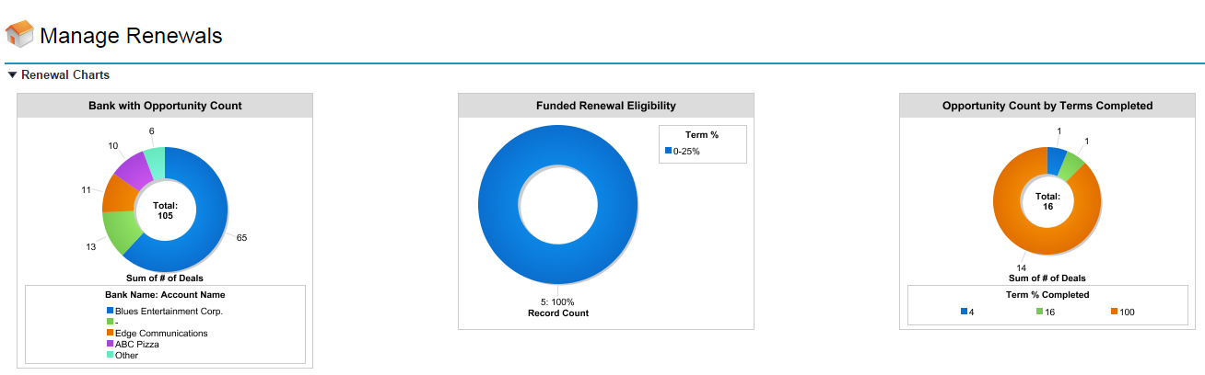

**Figure 43 – Manage Renewal Charts**

# 9.1 Renewal Charts

1. **Bank with Opportunity Count -** Displays the Bank with Opportunities.
2. **Funded Renewal Eligibility -** Shows the count of Opportunities which are eligible for Renewal with Terms% Completed range.
3. **Opportunity Count by Terms Completed -** Gives the count of Opportunities which are eligible for Renewal according to Terms% Completed.

* The below section displays the Eligible Contract for Renewal. From this, the users can create Opportunities & can also create FollowUp task for the selected Contracts.

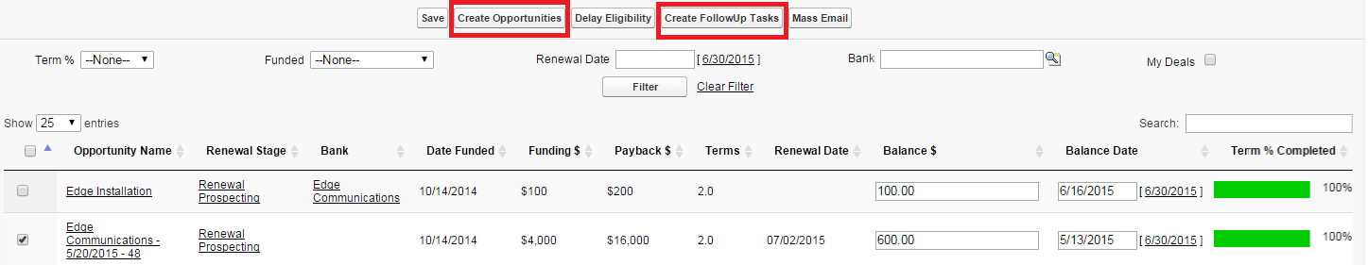

**Figure 44 – Manage Renewal Charts**

* On click of Create Opportunities button a pop-up window is shown in which the user can assign & create the opportunity owner or can click on **Cancel** commandLink.

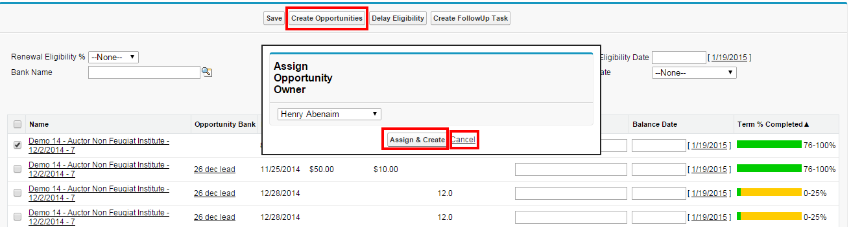

**Figure 45 – Manage Renewal Page**

# **Administration Panel**

* Navigate the **MCA Home** tab on Funding Automation application.

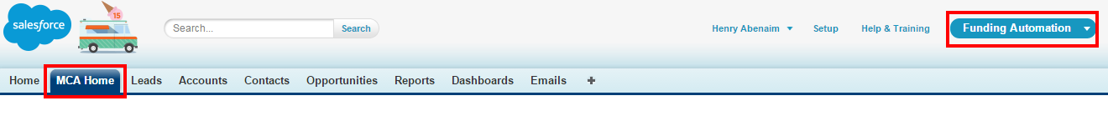

**Figure 46 – Funding Automation Application**

* Click the **Admin** icon shown on the MCA home page, which will navigate the Administration page.

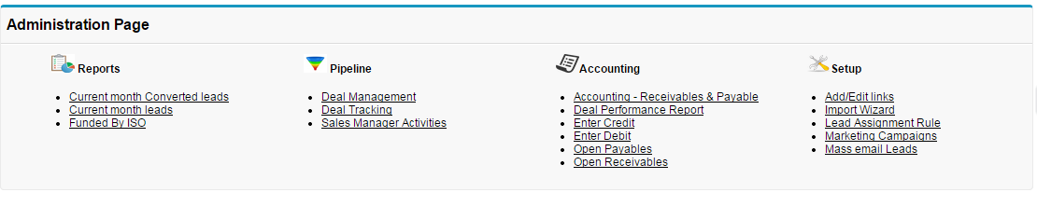

**Figure 47 – Administration Page**

* On click of any links provided under **Reports** section will navigate the corresponding report associated with the link.

For example, after clicking on the **Funded by ISO** link, it will redirect to the**Funded by ISO** reports as shown in *Figure 45*.

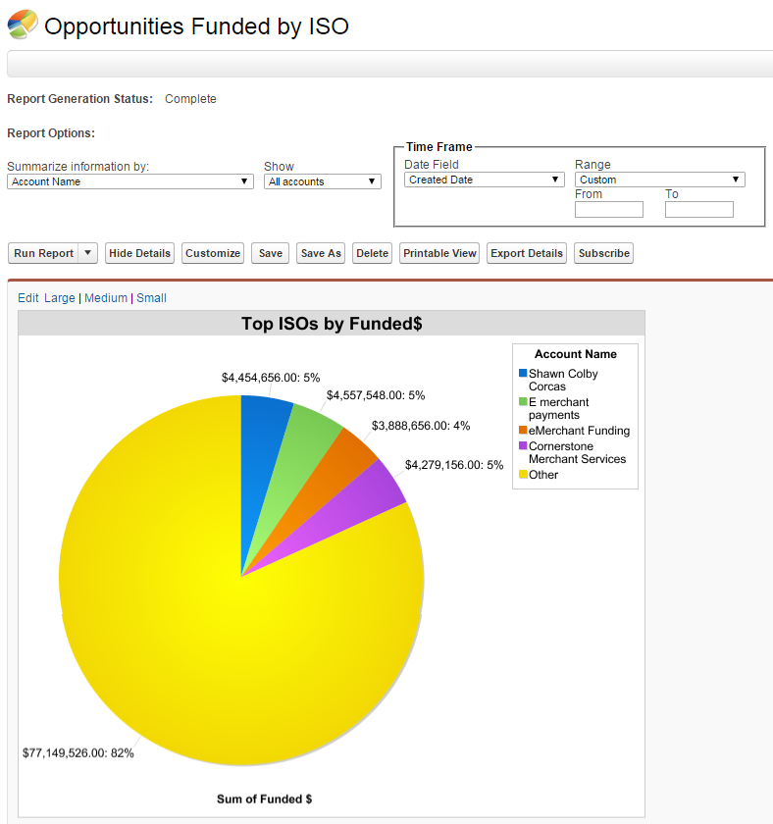

**Figure 48 – Funded by ISO**

* On click of any links provided under **Pipeline** section will navigate the corresponding report/ dashboard/ custom page associated with the link.

For example, after clicking on the **Manage Renewal** link, it will redirect to the **Manage Renewal custom page** as shown in *Figure 46*.



**Figure 49 – Manage Renewal Custom Page**

* On click of any links provided under **Accounting** section will navigate the corresponding report/ dashboard/ custom page associated with the link.

For example, after clicking on the **Accounting – Receivables & Payables** link, it will redirect to the **Accounting – Receivables & Payables dashboard** as in *Figure 47*.

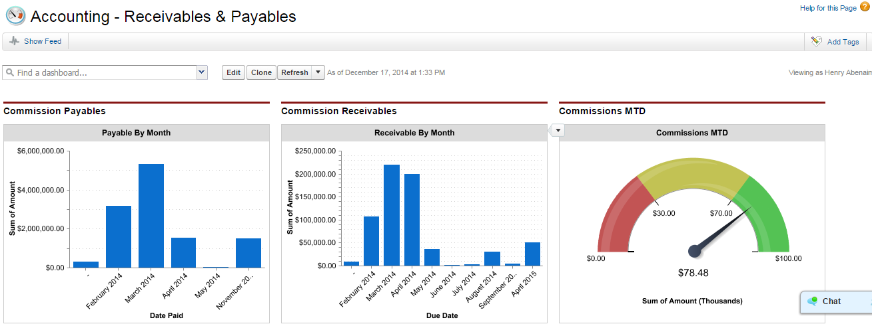

**Figure 50 – Accounting – Receivables & Payables Dashboard**

* On click of any links provided under **Setup** section will navigate the corresponding report/ dashboard/ custom page/ tab associated with the link.

For example, after clicking on the **Add/Edit** links, it will redirect to the custom settings section of the Administration page where all post deployment steps will be executed for the Administration page as shown in *Figure 48*.

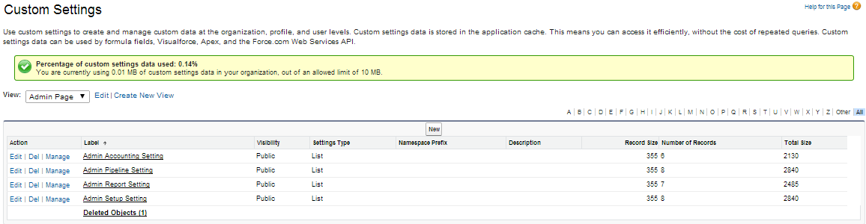

**Figure 51 – Custom Settings of Administration Page**

# Custom Lead Convert

* The custom convert lead functionality consists of converting the lead record to opportunity instead of converting it to the lead.
* Follow the below steps to convert the lead.
* Select **Lead** tab & click on either existing record or create the new record.
* Click on the **Convert Lead** button.

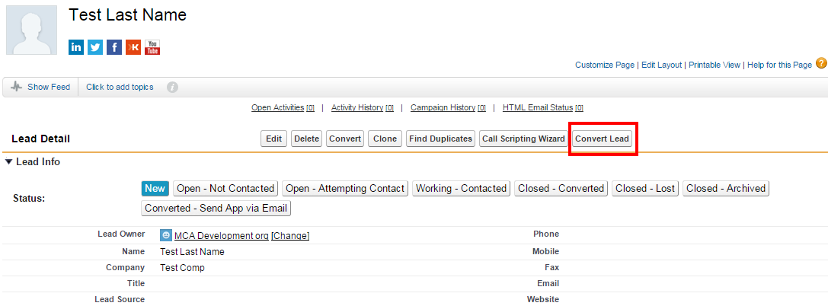

**Figure 52 :** **Lead Record Details**

* After the click on convert lead button, the page will redirect to other page where when checked on checkbox **Redirect to Funding Application Form** will navigate to the Funding Application page and also along its mandatory to create opportunity.

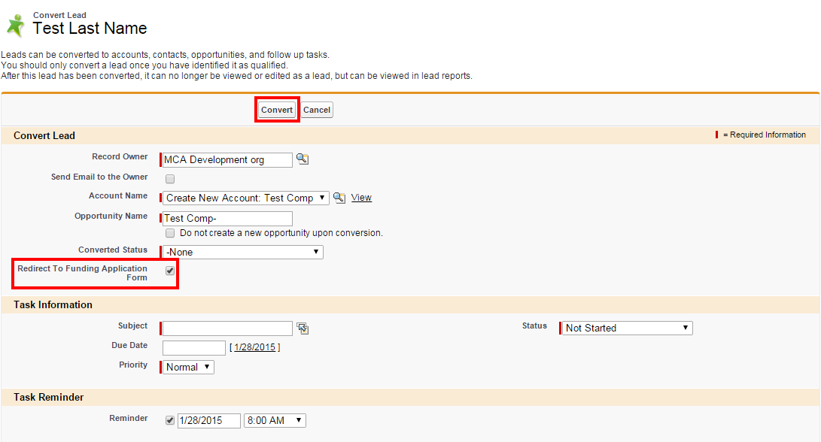

**Figure 53 :** **Lead convert page**

* On checking the checkbox , do not create a new opportunity upon conversion will & by click on the Convert button will not allow to convert the lead to convert into opportunity.

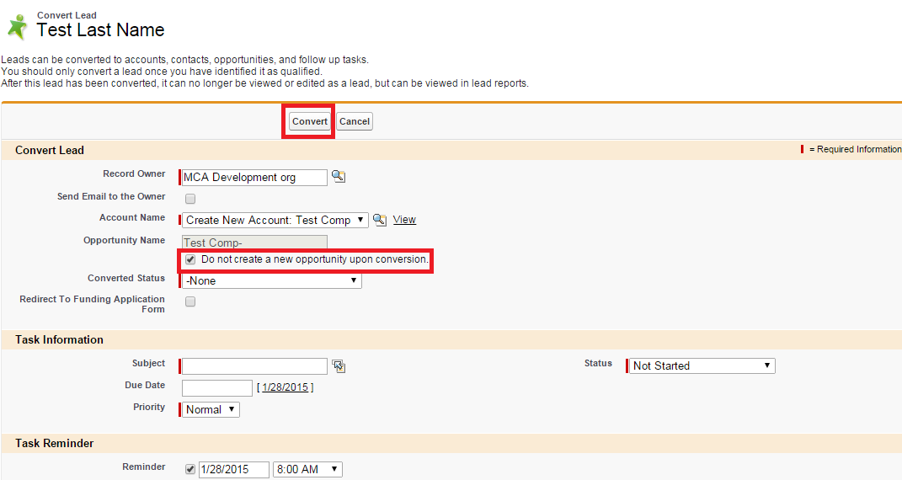

**Figure 54 :** **Lead convert page**

# **Appendix**

**Abbreviations and Keywords**

|  |  |  |
| --- | --- | --- |
| **Sr. No.** | **Term** | **Description** |
|  | Credit | Paid back amount to the lender |
|  | Credit score | Numerical expression based on a level analysis of a person's credit files |
|  | Debit | Received amount from the merchant |
|  | ISO | Independent Sales Office |
|  | Lenders | A lender can be an individual or a public or private group who provide funds for a variety of reasons, such as a mortgage, automobile loan or small business loan etc. |
|  | Renewal | To renew or extend the period of loan |
|  | Underwriters | Underwriters are large financial service provider who uses underwriting process to assess the eligibility of a customer to receive their products (equity capital, insurance, mortgage, or credit) |